|  |  |  |  |  |  |  |  |
| --- | --- | --- | --- | --- | --- | --- | --- |
| **Birchmeadow Fire Alarm System: Record of Events other than False Alarms or Maintenance Work** | | | | | | | |
| **Date** | **Time** | **Event (eg: test, fire alarm signal)** | **Zone** | **Device** | **Action required** | **Date completed** | **Initials** |
|  |  |  | Z1 | D3 |  |  |  |
|  |  |  | Z2 | D1 |  |  |  |
|  |  |  | Z2 | D4 |  |  |  |
|  |  |  | Z2 | D7 |  |  |  |
|  |  |  | Z2 | D9 |  |  |  |
|  |  |  | Z2 | D13 |  |  |  |
|  |  |  | Z2 | D18 |  |  |  |
|  |  |  | Z3 | D1 |  |  |  |
|  |  |  | Z3 | D3 |  |  |  |
|  |  |  | Z3 | D5 |  |  |  |
|  |  |  | Z3 | D8 |  |  |  |
|  |  |  | Z1 | D3 |  |  |  |
|  |  |  | Z2 | D1 |  |  |  |
|  |  |  | Z2 | D4 |  |  |  |
|  |  |  | Z2 | D7 |  |  |  |
|  |  |  | Z2 | D9 |  |  |  |
|  |  |  | Z2 | D13 |  |  |  |
|  |  |  | Z2 | D18 |  |  |  |
|  |  |  | Z3 | D1 |  |  |  |
|  |  |  | Z3 | D3 |  |  |  |
|  |  |  | Z3 | D5 |  |  |  |
|  |  |  | Z3 | D8 |  |  |  |
|  |  |  | Z1 | D3 |  |  |  |
|  |  |  | Z2 | D1 |  |  |  |
|  |  |  | Z2 | D4 |  |  |  |
|  |  |  | Z2 | D7 |  |  |  |
|  |  |  | Z2 | D9 |  |  |  |
|  |  |  | Z2 | D13 |  |  |  |
|  |  |  | Z2 | D18 |  |  |  |
|  |  |  | Z3 | D1 |  |  |  |
|  |  |  | Z3 | D3 |  |  |  |
|  |  |  | Z3 | D5 |  |  |  |
|  |  |  | Z3 | D8 |  |  |  |

|  |  |  |  |  |  |  |
| --- | --- | --- | --- | --- | --- | --- |
| **Birchmeadow Fire Alarm Fault Log** | | | | | | |
| **Date** | **Time** | **Zone** | **Event** | **Action required** | **Date completed** | **Initials** |
|  |  |  |  |  |  |  |
|  |  |  |  |  |  |  |
|  |  |  |  |  |  |  |
|  |  |  |  |  |  |  |
|  |  |  |  |  |  |  |
|  |  |  |  |  |  |  |
|  |  |  |  |  |  |  |
|  |  |  |  |  |  |  |
|  |  |  |  |  |  |  |
|  |  |  |  |  |  |  |
|  |  |  |  |  |  |  |
|  |  |  |  |  |  |  |
|  |  |  |  |  |  |  |
|  |  |  |  |  |  |  |
|  |  |  |  |  |  |  |
|  |  |  |  |  |  |  |
|  |  |  |  |  |  |  |
|  |  |  |  |  |  |  |
|  |  |  |  |  |  |  |
|  |  |  |  |  |  |  |
|  |  |  |  |  |  |  |
|  |  |  |  |  |  |  |
|  |  |  |  |  |  |  |
|  |  |  |  |  |  |  |
|  |  |  |  |  |  |  |
|  |  |  |  |  |  |  |
|  |  |  |  |  |  |  |
|  |  |  |  |  |  |  |
|  |  |  |  |  |  |  |
|  |  |  |  |  |  |  |
|  |  |  |  |  |  |  |
|  |  |  |  |  |  |  |
|  |  |  |  |  |  |  |

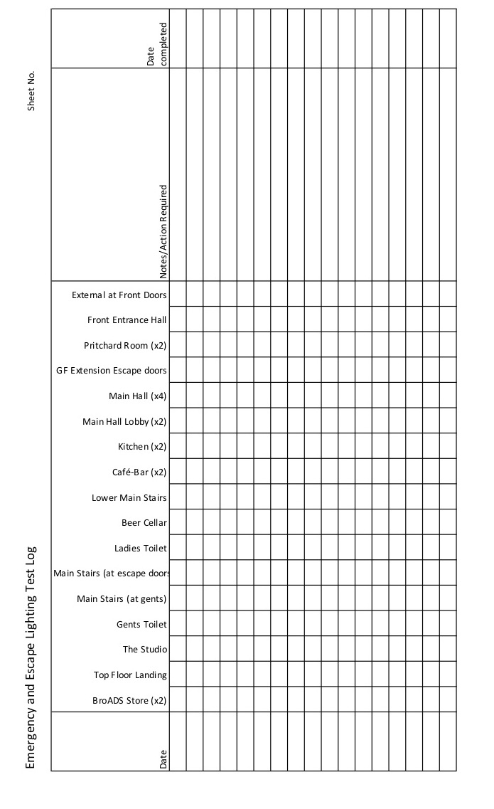

**Birchmeadow Fire Extinguishers: Records of Tests and Inspections**

(Maintenance of Portable Fire Extinguishers as recommended by BS 5306 Part 3)

**Routine monthly inspection by Birchmeadow Centre management:**

1. All extinguishers are in their proper positions

2. No extinguishers have been discharged, suffered damage or are missing parts

3. All extinguishers are free from obstruction and visible

4. The operating instructions on each extinguisher are clean, legible and face outwards

5. The seals and tamper indicators on each extinguisher are not broken or missing

6. In case of extinguishers fitted with a pressure indicator, no loss of pressure is shown on the dial

**Annual inspection, service and maintenance by a competent person**

The above BS also recommends annual servicing and maintenance and that these should be carried out by a competent person with the qualifications, training and experience and having the relevant equipment, information, manuals and knowledge of any special procedures recommended by the manufacturer of an extinguisher to carry out the relevant maintenance procedures.

At the time of writing (August 2018) these duties were undertaken by ABC Fire Protection on behalf of Broseley Town Council

**Birchmeadow Fire Extinguishers:**

**Records of Routine Monthly Tests and Inspections**

|  |  |  |  |  |  |
| --- | --- | --- | --- | --- | --- |
| **Date** | **Number/Location** | **Inspected or Tested** | **Satisfactory**  **Yes/No** | **Action Taken** | **Initials** |
|  | 1. Entrance lobby (foam) |  |  |  |  |
|  | 2. Dressing room corridor (foam) |  |  |  |  |
|  | 3. Main hall to L of stage (foam) |  |  |  |  |
|  | 4. On stage below fuseboards (CO2) |  |  |  |  |
|  | 5. Kitchen adj boilers (foam) |  |  |  |  |
|  | 6. Kitchen adj fridge (CO2) |  |  |  |  |
|  | 7. Kitchen (NB fire blanket) |  |  |  |  |
|  | 8. Top floor landing (CO2) |  |  |  |  |
|  | 9. Landing adj Studio (foam) |  |  |  |  |
|  | 10. Top floor landing (foam) |  |  |  |  |
|  | 11. Beer cellar (CO2) |  |  |  |  |
|  | 12. Hall adj entrance doors (foam) |  |  |  |  |
|  | 13. Dressing room (foam) |  |  |  |  |
|  |  |  |  |  |  |

**Birchmeadow Fire Extinguishers:**

**Records of Annual Tests and Inspections**

|  |  |  |  |  |  |
| --- | --- | --- | --- | --- | --- |
| **Date** | **Number or**  **Location** | **Inspected or Tested** | **Satisfactory**  **Yes/No** | **Action Taken** | **Signature** |
|  |  |  |  |  |  |
|  |  |  |  |  |  |
|  |  |  |  |  |  |
|  |  |  |  |  |  |
|  |  |  |  |  |  |
|  |  |  |  |  |  |
|  |  |  |  |  |  |
|  |  |  |  |  |  |
|  |  |  |  |  |  |
|  |  |  |  |  |  |
|  |  |  |  |  |  |
|  |  |  |  |  |  |
|  |  |  |  |  |  |
|  |  |  |  |  |  |
|  |  |  |  |  |  |
|  |  |  |  |  |  |

NB This form to be completed by Fire Extinguisher Specialist appointed by Broseley Town Council